**Vitalik Buterin Biography**

*By Sean Murphy (19335002) for CSU33012 – Software engineering*

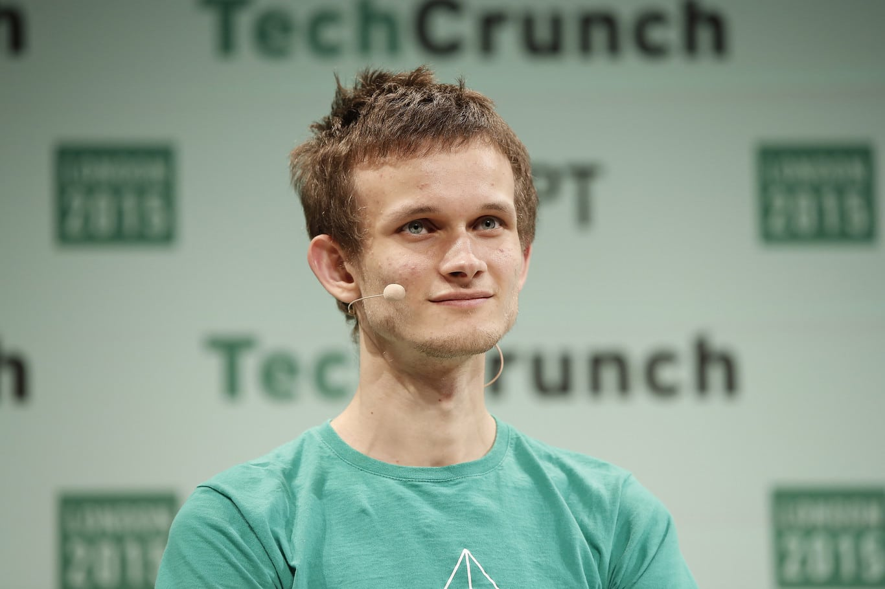

**Background**

Vitalik Buterin is a Russian-Canadian Software Engineer, known for being the main co-creator of Ethereum and a pioneer in the world of Cryptocurrency. He was born on 31 January 1994, in Kolomna, Russia. His parents emigrated to Canada when he was 6 years old. Vitalik was emersed in software from a young age due to his father being a computer scientist. He learned about Bitcoin from his father when he was 17 years old. Bitcoin, the first Cryptocurrency, is a fully decentralized digital currency with a fully open-source underlying technology that has a public encrypted ledger allowing the world to see the distribution and transfer of wealth held by the anonymous holders of the digital asset that is Bitcoin.

**Bitcoin Magazine**

Vitalik’s intrigue with bitcoin really began in 2011 when he began writing articles for a publication called ‘Bitcoin weekly’. He was paid 5 bitcoin per article which was about $3.50 at the time and now 10 years on is worth over $300,000 (20/10/2021). In late 2011, he co-founded his own publication ‘Bitcoin Magazine’, which resulted in a job offer a year later from the founder of Ripple, which minted the XRP Cryptocurrency token that sits in the top 10 crypto’s today (20/10/2021). The offer fell apart as Buterin could not obtain a US visa. This frustrated Buterin so he decided to create his own decentralized currency.

**Ethereum and Blockchain**

In late 2013, Vitalik published the Ethereum whitepaper, which he shared with his friends who subsequently shared it on themselves. In the coming weeks, about 30 people contacted Vitalik to discuss the concept. The concept evolved from a digital currency to a blockchain that supports multiple different functions such as developing DApps, decentralized applications and programs with the power of cryptos such as Ether, Ethereum’s token, and smart contracts which are essentially an agreement between a contract creator and the recipient. This agreement is written in code and added to the blockchain making it both unchangeable and irreversible. Blockchain is a coded system of recording information in a particular way that makes it impossible to change, alter or hack the system. Each block in the chain contains several transactions, and every time a new transaction occurs on the blockchain, a record of that transaction is added to every participant’s ledger. The digital ledger of transactions is continuously distributed across the network of computer systems on the blockchain.

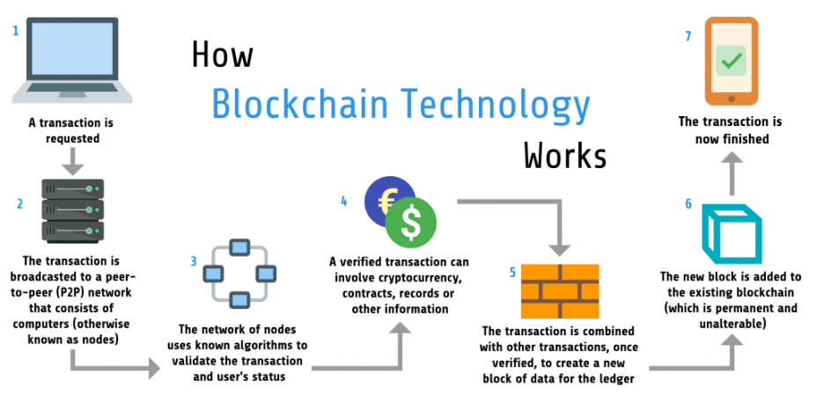

**Smart contracts and DApps**

If we were to compare smart contracts to that of a vending machine. Vending machines provide a user with a product, without the need for a person to accept money or hand over a product. Smart contracts have the same concept but are much more versatile. Smart contracts can be used in the world of real estate, insurance, supply chain management and the creation of digital identities. Smart contracts and blockchain are still not perfect. They are programmed by hand and human error is possible which can lead to exploitation from hackers which is known to have happened in the past.

DApps (decentralized applications) work by having their own backend code (smart contracts) running on a decentralized network. They use the Ethereum blockchain for data storage and smart contracts for their app logic. Once DApps are deployed on the Ethereum network you can’t change them. They are no controlled by an individual or company so they can be decentralized because they are controlled by the logic written in the contract itself.

**Why Vitalik Buterin?**

I decided to do my essay on Vitalik Buterin as I have a big interest in cryptocurrency and the technology of blockchain. I study business alongside computer science in Trinity college so finance also interests me. I often imagine and enjoy the idea of financial institutions like banks being totally obsolete and where global wealth is completely decentralized.

I feel that Vitalik Buterin has been a pivotal figure in making this possibility a reality. He has knowledge beyond his years, publishing the Ethereum whitepaper when he was only 19 years old. I believe he still has many more successes and new ideas to bring to the world and Cryptocurrency space as a software engineer. Cryptocurrency, only recently was believed to be a Ponzi scheme and disregarded by some of the most famous investors in the world such as Warren Buffet and the JP Morgan CEO, Jamie Dimon, who said “Cryptocurrency is only fit for use by drug dealers, murderers and people living in North Korea.” Today, the asset class has a market capitalization of over 2 trillion dollars, with Ethereum being the second highest ranked, holding 15% of the entire market, only behind Bitcoin.

**Sources**

[**Wikipedia - Vitalik Buterin**](https://en.wikipedia.org/wiki/Vitalik_Buterin)

[**CoinTelegraph - Ethereum For Beginners**](https://cointelegraph.com/ethereum-for-beginners/who-is-vitalik-buterin)

[**EuroMoney - What Is Blockchain**](https://www.euromoney.com/learning/blockchain-explained/what-is-blockchain)

[**Ethereum Website**](https://ethereum.org/)

[**Business Insider - Celebrities Who Back Bitcoin**](https://www.businessinsider.com/13-celebrities-who-back-cryptocurrency-and-may-own-millions-in-bitcoin-2019-1?r=US&IR=T)

[**Business Insider - Vitalik Buterin**](https://www.businessinsider.com/vitalik-buterin-created-ethereum-one-of-the-worlds-three-largest-cryptocurrencies-2019-1?r=US&IR=T)

[Bitcoin vs Ethereum - What’s The Difference?](https://www.investopedia.com/articles/investing/031416/bitcoin-vs-ethereum-driven-different-purposes.asp)